Sparse Vector Binding

# Binding Scheme







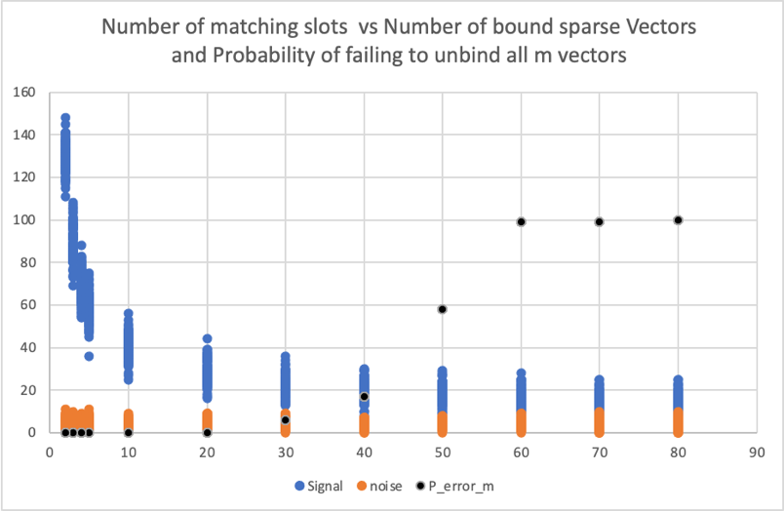

# Theory

B is the number of bit positions

m is the number of sparse vectors to be added (including the target vector)

D is a parameter that defines if we want to determine the probability of a winning pattern (D=0) or a pattern where there is the probability of a draw D=1)

We define the Pattern as arrays of elements *E* and counts *C* of the sum before adding the target pattern.

$E= \left[E_{1} ,E_{1}…E_{i} \right]$: $E_{i} > E_{i-1}$

$$C= \left[C_{1} ,C_{1}…C_{i} \right]$$

If D = 0, W = 1

If D = 1 and $E_{k}- E_{k-1}=1$, W = $C_{k}+1$

If $E_{1}=0 then C_{1}=1$

Here are some examples:

Example 1

Pattern = 2 0 1 0 0 3 0 2 0 1 0 1 0 0 1 0

Target = 1 0 0 0 0 0 0 0 0 0 0 0 0 0 0 0

Sum = 3 0 1 0 0 3 0 2 0 1 0 1 0 0 1 0

m = 12

B = 16

*E* = [0,1,2,3]

C = [1,4,2,1]

Example 2

Pattern = 2 1 2 1 1 2

Target = 1 0 0 0 0 0

Sum = 3 1 2 1 1 2

m = 10

B = 6

E = [1,2]

C = [3,3]

Number of possible patterns combinations

$$P_{n} = \frac{\left(m-1\right)!}{\prod_{i=1}^{k}{{\left[E_{i}!\right]}^{C_{i}}}}$$

Number of arrangements

If D = 0, $C_{k}=C_{k}-1$

If D = 1, $C_{k-1}=C_{k-1}-1$

Denote $C as C^{'}$ to indicate this and then:

$$A_{n}= \frac{\left[\sum_{i=1}^{k}{C_{i}^{'}}\right]!}{\prod_{i=1}^{k}{\left[C_{i}^{'}\right]}!}$$

Number of repeats

$$R_{n}= \left(\frac{\left(B-1\right)}{\sum_{i=1}^{k}{C_{i}^{'}}}\right)$$

Where $\left(\frac{a}{b}\right)$ is the number of combinations of b in a. Alternatively we can write:

$$R_{n}= \left(\frac{\left(B-1\right)!}{\left[B-1- \sum_{i=1}^{k}{C_{i}^{'}}\right]!×\left[\sum_{i=1}^{k}{C_{i}^{'}}\right]!}\right)$$

Pattern Probability

$$P= \frac{P_{n} × A_{n} ×R_{n} }{B^{m-1}× W}$$

or





$$P= \frac{\left(m-1\right)!×\left(B-1\right)!}{\prod_{i=1}^{k}{{\left[E_{i}!\right]}^{C_{i}}}×\prod_{i=1}^{k}{\left[C_{i}^{'}\right]}!×\left[B-1- \sum_{i=1}^{k}{C_{i}^{'}}\right]×B^{m-1}× W}$$

Code in Patterns6_1.py

from __future__ import generators

import numpy as np

import math

from scipy.special import factorial

from scipy.misc import comb

from scipy.special import perm

def calc_prob(elements,counts,B,D):

E = np.array(elements)

C = np.array(counts)

l = len(C) - 1

EC = E*C

Pn = num_patterns(E,C)

if D == 0:

C[l] -= 1

W = 1

else:

C[l-1] -= 1

W = counts[l] + 1

An = num_arrangements(C)

Rn = num_repeats(B,C)

P = Pn*An*Rn/(W * np.float_power(B,m-1))

return P

def num_patterns(E,C):

F = factorial(E)

Fp = np.power(F,C)

Pn = factorial(m-1)/np.product(Fp)

return Pn

def num_arrangements(C):

F = factorial(C)

An = factorial(sum(C))/np.product(F)

return An

def num_repeats(B,C):

Rn = comb(B-1,sum(C))

return Rn

def accel_asc(n):

a = [0 for i in range(n + 1)]

k = 1

y = n - 1

while k != 0:

x = a[k - 1] + 1

k -= 1

while 2 * x <= y:

a[k] = x

y -= x

k += 1

l = k + 1

while x <= y:

a[k] = x

a[l] = y

yield a[:k + 2]

x += 1

y -= 1

a[k] = x + y

y = x + y - 1

yield a[:k + 1]

def get_result(m,B,M):

cnt=0

p_cnt=0

w_cnt=0

d_cnt=0

P_sum = 0

T = 1.0

for value in accel_asc(m-1):

a = np.array(value)[::-1]

if len(a) <=B:

p_cnt +=1

elements, counts = np.asarray(np.unique(a,return_counts=True))

E = [0]

C = [0]

for i in range(0,len(elements)):

E.append(elements[i])

C.append(counts[i])

D = 0

P = calc_prob(E,C,B,D)

P_sum += P

w_cnt += 1

if P>=T:

print (a,P,P_sum,'W')

#If can be shared win divide by i_a

l = len(E) - 1

if l>=1 and E[l] - E[l-1] ==1:

p_cnt += 1

D = 1

if E[l] == 1:

C[0] = 1

P = calc_prob(E,C,B,D)

P_sum += P

d_cnt += 1

if P>=T:

print (a,P,P_sum,'D')

print(P_sum*M)

'''

print(m,B,M,'sum=',P_sum,P_sum*M)

print('Pattern Count=',p_cnt)

print('win count=',w_cnt)

print('draw_cnt=', d_cnt)

'''

B = 512

M = 256

print("Num_slots=",M,"Num_bits=",B)

for m in range(2,82,2):

get_result(m,B,M)

# Results











